CIT Mid Question Solution | Session 2019-20

1) One hundred students were asked whether they had taken courses in any of the three areas, sociology, anthropology, and history. The results were:
48 had taken sociology
38 had taken anthropology
21 had taken history
18 had taken sociology and anthropology
9 had taken sociology and history
4 had taken history and anthropology
and 23 had taken no courses in any of the areas.
(a) Draw a Venn diagram that will show the results of the survey.
(b) Determine the number k of students who had taken classes in exactly
(I ) one of the areas, and
(II) two of the areas.

(a) Here is a Venn diagram showing the above data,
Let,
S = sociology students
A = anthropology students
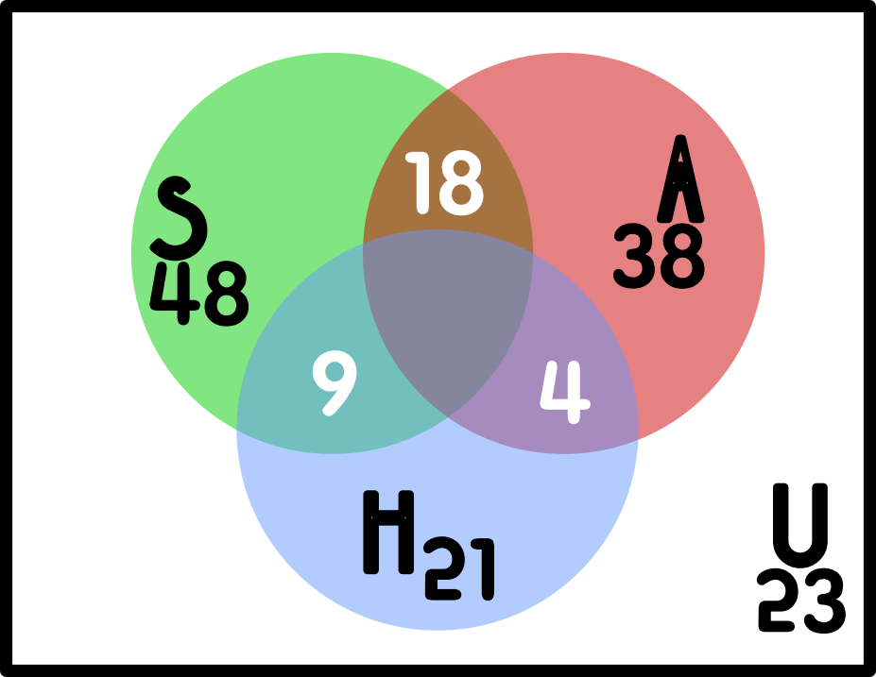
H = history students

(b) Students,
Here,
total students = 100
So, considering x as the students who have taken both 3 subjects,
48 + 21 + 38 – 18 – 9 – 4 + x = 100
or, x = 1

students,
taken only sociology = 48 - ( 9 + 18 - 1 ) = 22
taken only history = 21 - ( 9 + 4 - 1 ) = 9
taken only anthropology = 38 - ( 4 + 18 - 1 ) = 17
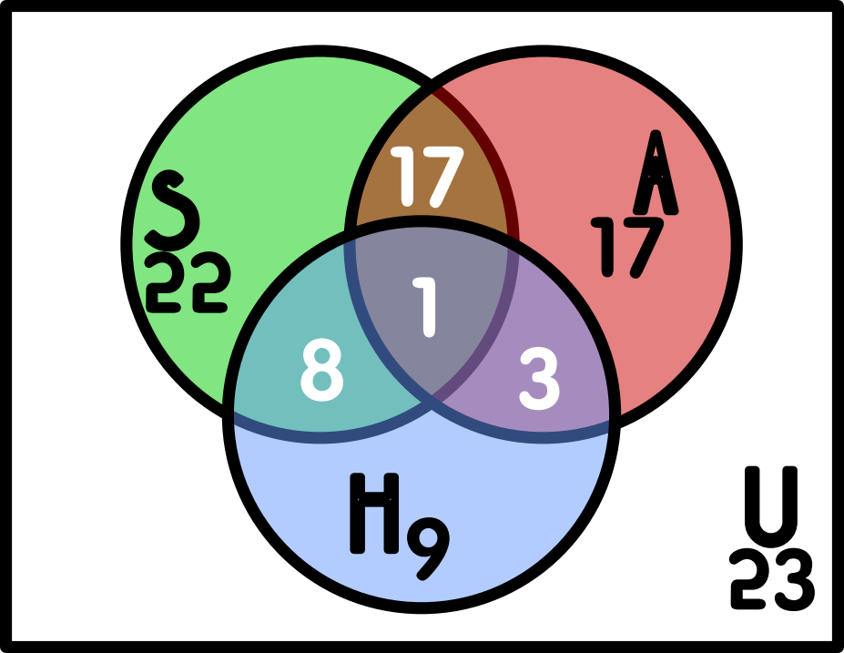
So, students taken one of these = 22 + 9 + 17 = 48
And, students taken two of the areas = 8 + 3 + 17 = 28

Solution to this problems answer differs from place to place. For example, https://brainly.in/question/23019587 , this website will tell you the answer, 42 and 31. Chat GPT will 45 and 31. But I followed a similar answer from the book “Discrete math by Kenneth”, page 16, chapter 1, problem 1.15 (set theory). Fell free to correct me!

2) What is proposition? Show that (P^Q) → (P˅Q) is a tautology.

A proposition is a declarative sentence (that is, a sentence that declares a fact) that is either true or false, but not both (source, Kenneth book)

Let’s consider a truth table for (P^Q) → (P˅Q),
P | Q | P^Q | P˅Q | (P^Q) → (P˅Q)
T | T | T | T | T
T | F | F | T | T
F | T | F | T | T
F | F | F | F | T
Here, for every possible values for P and Q variables, the result (P^Q) → (P˅Q) is always true. So we can deduce it as a tautology.

3) Define Universal Quantification. Let Q(x) be the statement “x<2”. What is the truth value of the quantification ∀xQ(x), whose the domain consist of all real numbers?

Universal Quantification
In mathematical logic, a universal quantification is a type of quantifier, a logical constant which is interpreted as "given any", "for all", or "for any". It expresses that a predicate can be satisfied by every member of a domain of discourse.

Q(x) is not true for every real number x, because, for instance, Q(3) if false. That is, x = 3 is a counterexample for the statement ∀xQ(x), Thus,
∀xQ(x)
is false.

source, kenneth book page 45

